* The most familiar one is SQL Server installed in a Windows server machine 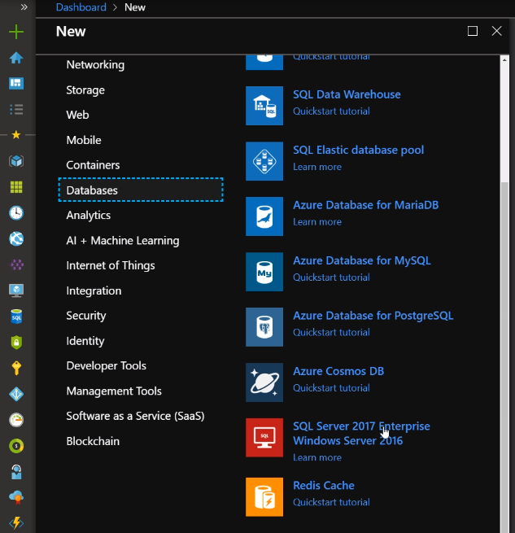
* SQL Database Platform as a service which is used as Database as a service.
* <https://docs.microsoft.com/en-in/azure/sql-database/sql-database-technical-overview>
* Migrating when we need a higher plan for performance.
* Azure SQL Managed Instance lets you migrate data and let azure take care of other infrastructure related stuff.
* Many Services related to SQL and NO-SQL 